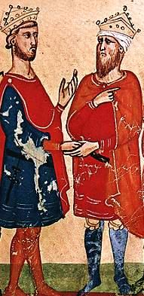[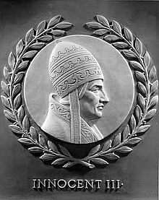](http://www.google.co.uk/url?sa=i&rct=j&q=innocent+iii&source=images&cd=&cad=rja&docid=oZCc862qzvpfMM&tbnid=Ac5SjcIGWy7LaM:&ved=0CAUQjRw&url=http://en.wikipedia.org/wiki/Pope_Innocent_III&ei=d3azUeulJ6W80QXN3YCQCg&psig=AFQjCNG-X1Dbo_ZAg2qedxz_mPLDXIoXvQ&ust=1370802135809335)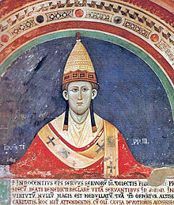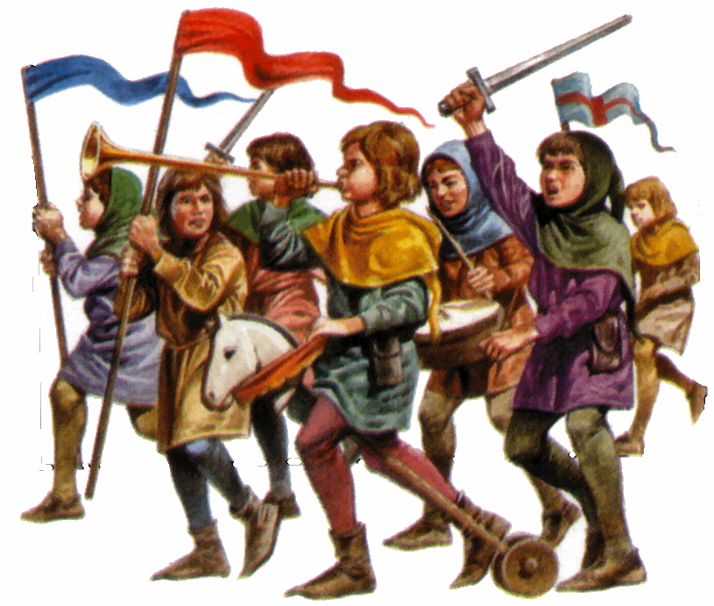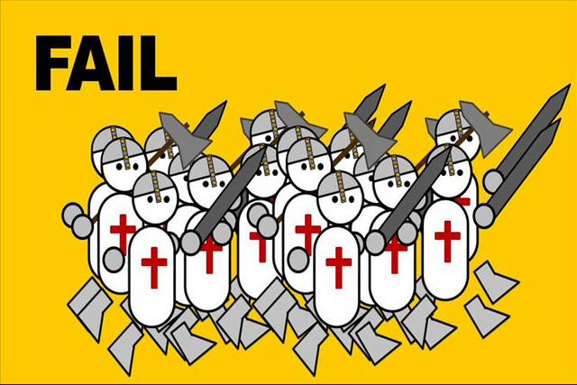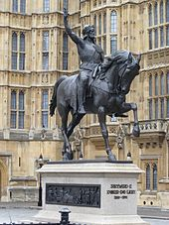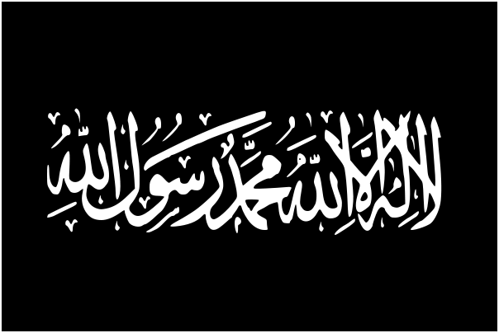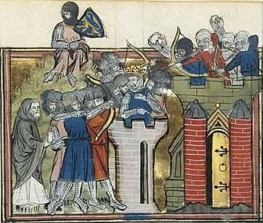



**Card 9: Hot or Not**

Louis IX again attacked the Arabs in Tunis in North Africa. He picked the hottest season of the year for campaigning and his army was devastated by disease. The king himself died, ending the last major attempt to take the Holy Land.



**Card 7: It seems that God wishes to support the Turks**

Despite the loss of Jerusalem and despite calls from the Pope, there was no popular enthusiasm for yet another new crusade. It seemed as though most Europeans were losing interest in the Holy Land.

**CARD 5: Siege of Jerusalem**

Jews and Muslims fought together to defend Jerusalem against the Christians. The crusaders entered the city and massacred the inhabitants and even destroying mosques and synagogues.

**Card 1: Suffer the children**

The innocence of a child was thought to be a way to get God’s blessing and retake the Holy Land. Sadly most of these poor children died or were sold into slavery. Few ever reached the Holy Land.

**Card 8: Friend or foe**

The Crusaders run out of money and resources and decide to attack their own ally; friend and fellow Christian state the Byzantine Empire, sacking Constantinople. Most Crusaders fail to reach the Holy Land.

**Card 6: King Richard I of England (Richard the Lionheart)**

German King Frederick I Barbarossa drowns on the way to the Holy Land and an English King manages to capture Acre.

**CARD 3: Jihad**

The Saracens started to have decisive victories in the Holy Land. An Islamic ruler called Saladin united many in Jihad against the Crusaders. The Crusaders would lose Jerusalem.

**Card 2: Yet another failure**

This time organised by yet another Pope - Pope Innocent III, this Crusade started well but the army split in two and failed to get important supplies and siege equipment in time. The Crusade was such a failure that many people not only criticised Pope Innocent III but also the church.

*Frederick II (left) meets al-Kamil (right).*

**Card 4: Success at last…**

With very little fighting Frederick II was able to peacefully negotiate with the Muslim leader al-Kamil.